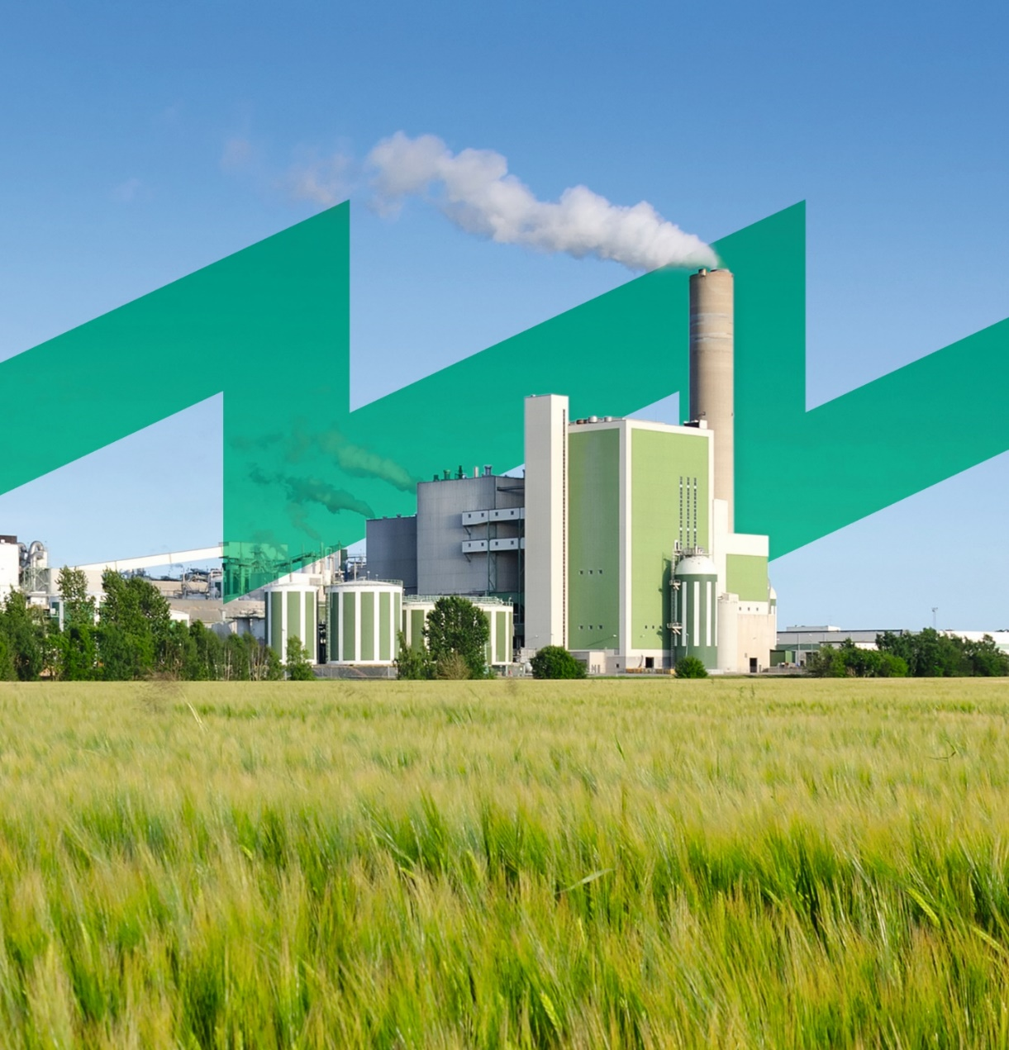

Role Play:
Initiatives in Energy Efficiency
INDUCE
Towards a Sustainable agro-food INDUstry
Capacity building programmes in Energy efficiency
This project has received funding from the European Union’s H2020 Coordination Support Action under Grant Agreement No.785047.

“This role play is useful to know which ideas are important within the company, to a greater or lesser extent. In this way the ideas are placed in order of importance, according to the general opinion of the group. Similarly, based on the discussions and explanations of the participants you can know the general opinion about certain measures.”

Methodology

Thinking ideas
- A set of papers (for example 3) will be distributed to each participant where you will have to write down three important ideas to improve on energy efficiency issues in the company.
- These ideas can be of various types: organizational, communication, logistics...

Discussion of ideas
- The participants will be divided into several groups (around 5 people per group). Once in the group, ideas generated by the participants will be discussed.
- The first step will be to group the ideas by types. (Keep in mind that many of the ideas that are generated are the same or similar, also that many ideas can be the solution of others).
- In this way, each idea will not be a "simple concept", but it will be developed along with similar ideas.
- Finally, among the five members of the group, they should discuss which is the five most important ideas for them and how to implement it in the company. Criteria such as:
  - Technical facility
  - Information or transmission within the company
  - Required investment

Presentation of ideas
- In this phase, each group will present their 3 ideas to the other groups, they should explain the importance of the ideas, which is the reason why the idea should be implemented, the selection criteria previously named. They should also explain the inconveniences of it.The rest of the participants can ask the questions they consider necessary.

The tree of decisions
- In this phase, all the participants together will put in order the ideas generated by the groups. For this, we will use the help of the tree of decisions.
- The tree is our company and we must place the different ideas depending on the concept and the importance that the participants have on it. In this way:
  - The leaves are used by the tree to show others. Also, they are responsible for photosynthesis, so they not only perform functions of brilliance, but also vital functions.In this way, in the leaves of the tree we will place the ideas that the group assumes that are less important, or that at least they are not relevant for the energetic functioning of the company. Although, if they are important for "the energy brand" and how the company is shown abroad, also those that promote communication and awareness of employees.
  - The trunk is responsible for supporting the tree and joining the branches and leaves with the roots. The tree could not stand without the trunk. Thus, in the trunk are placed the ideas that are important for the proper functioning of the company.
  - The roots are responsible for anchoring the tree to the ground, also have the function of feeding the tree. For this reason, in the roots the fundamental and important ideas for the company will be placed.
- For the distribution of ideas in a democratic way, the trainer will select an idea and place it on the top of the tree. All participants will raise their hands at that moment.
- Then the trainer will start descending the tree and the participants will have to lower the cunaod hand to consider that the idea should be placed on the tree.
- The idea will be placed on the tree, when a percentage (previemente thought) of the participants have lowered the hand (for example 75%).
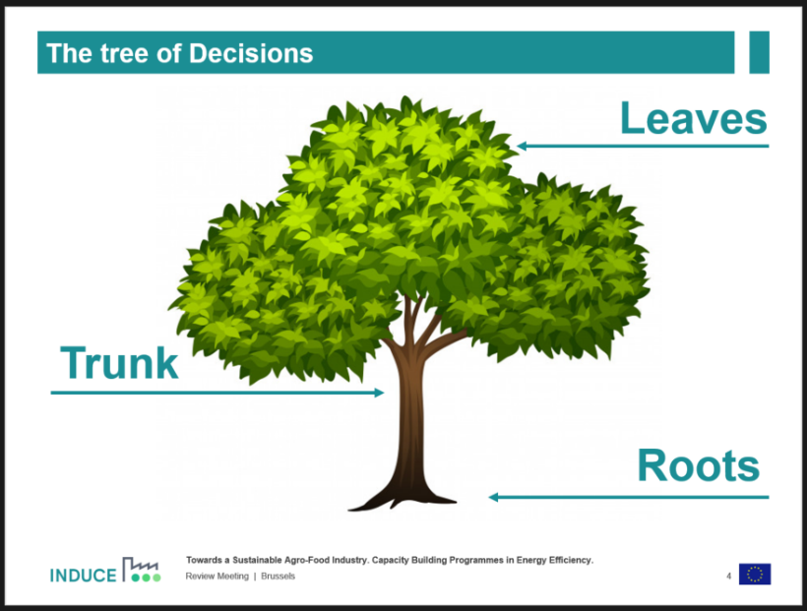
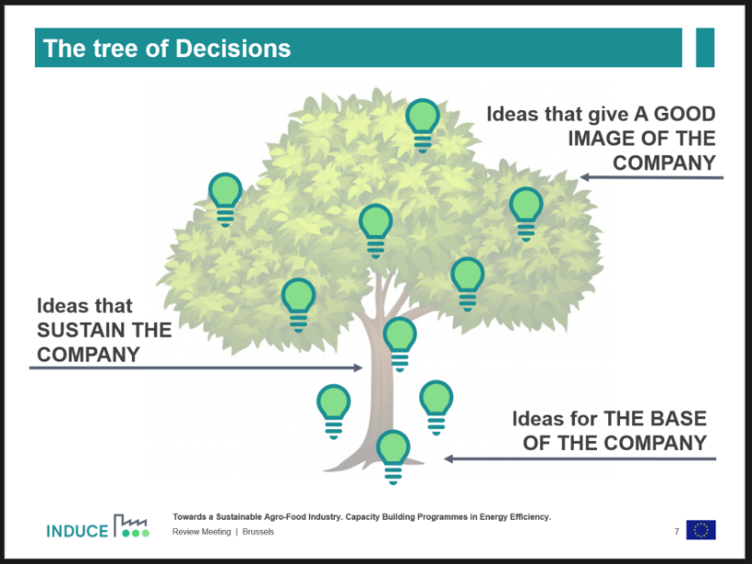

Materials
- Post-it´s and pens.
- A large sheet where to draw the tree.

