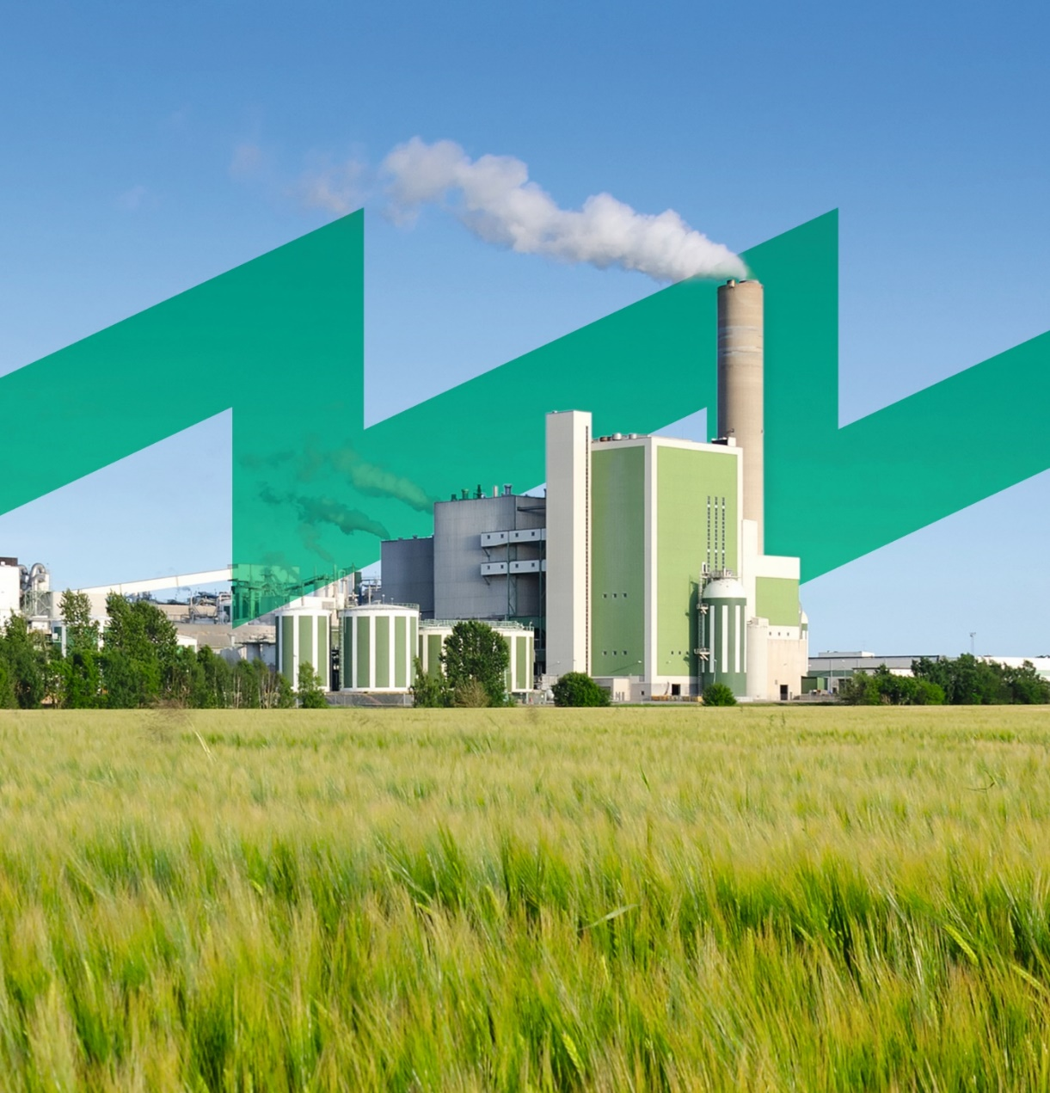

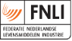
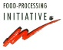
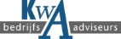
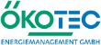
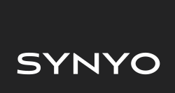
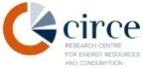
Role Play:
Communication & Cooperation in EnMS
INDUCE
Towards a Sustainable agro-food INDUstry
Capacity building programmes in Energy efficiency
This project has received funding from the European Union’s H2020 Coordination Support Action under Grant Agreement No.785047.

“This role play is prepared to know who are the agents that intervene in the Energy Management System. It also helps employees to know what their role is and in this way what tasks they can carry out and propose. This encourages communication within the company, also helps employees cooperate to achieve the same goal”.

Methodology

Introduction of Participants
- Stickers are distributed to the employees in which they have to write their name and their position in the company.
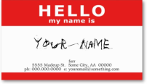
- The group should be divided by trainers in five groups with five people every group.
- Then, in their own group every student should do a round of presentation in which they should also explain the role they believe they perform regarding the energy efficiency of the company, the contact they have had with the Energy Management System and expectations of the workshop.

Energy-efficient staff
- The organization chart of the company regarding the Energy Management System is explained by trainer to all students.
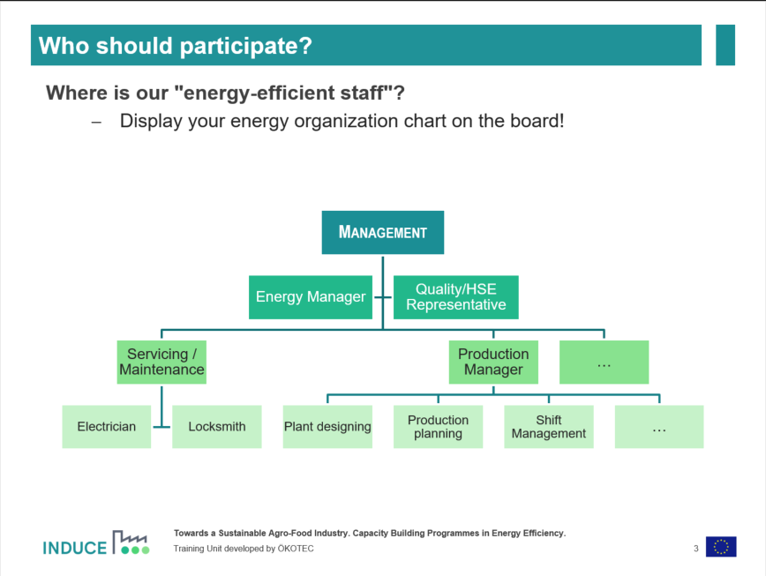
- At this point the participants can guess at what point their colleagues, their superiors and themselves observe whether or not it matches your initial idea.

Tasks
- Assign the tasks to the roles and complete what is missing!.
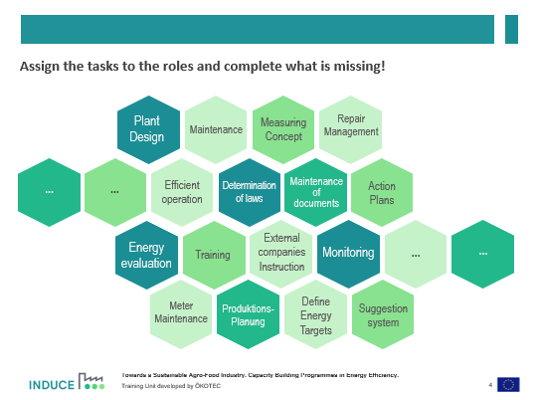
- In this phase the participants can express their opinion to complete the tasks.

Discuss part
- The trainer distribute the material to each group.
  - Thread or wool.
  - Cards with the name of the roles written on it.
  - Five yellow cards with nothing written and several red cards with nothing written.
- Participants must choose and write on the yellow cards the five topics that you want to discuss.
- Discuss with each of your assigned colleagues the following topics:
  - What are the key topics you should discuss regularly regarding EnMS? (Yellow cards)
  - Which means of communication are suitable ((existing/new) regular meetings, notice, regular report, etc.) for the relevant information? (Red cards)
  - How often/at which intervals should you communicate?

Present part
- Present your results:
  - Which means of communication did you choose?
  - Is there already a specific topic (machine design, energy saving action) which you will track?
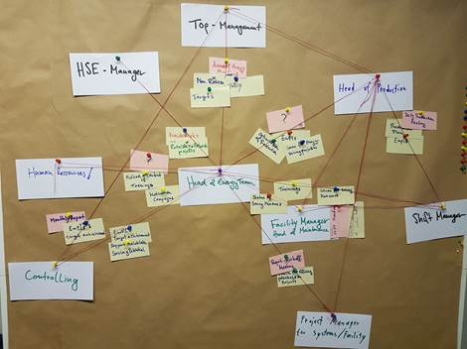
  - The different groups will explain the tasks they have chosen and marching on the pin board who are responsible and the media they have used. In this way (and not repeating tasks of the previous group) the result can be created by all the participants.

Summary results of the day
Pin Board Documentation with how the process should be organised from the perspective of the employees
  - “White Cards“ and “Cords“: People (Energy Team) and interaction
  - “Yellow Cards“: Topics that they need to discuss
  - “Red Cards“: Suitable Plattforms
The Pin Board is a good Input for the Management to adapt communi-cation process of Energy Management System to the natural communication process in the company

Materials
- Stickers for the name.
- Thread or wool.
- Pin board.
- Thumbtacks.
- Color cards.

Additional information for trainers.
In this section, it is given additional information to make emphasis if it is necessary according to different needs in the company.
If you shall be successful in reducing your energy use, everybody needs to contribute, and in order to do that, everybody needs to know what’s going on. Thus, internal communication is vital for a well-functioning EnMS. You need to inform all employees about the company’s energy use and costs and show them how they can contribute to influence it.

How to
Suggested first-time procedure:
- Inform all employees that you have set up an Energy team and will start to work actively with energy savings. (include it in slide3).
- Within the team, discuss how you should communicate your energy use and actions. Some ideas are listed in the section below.
- Discuss a system for collecting suggestions from all staff. All staff should know who they can talk to if they come up with an idea. You may also put up a letterbox for this purpose.
Suggested revision procedure:
Internal communication will be a very important part of your energy management system, and you need to work with it continuously. Set up routines for reporting the energy use regularly (e.g. once per month or every six months). Discuss regularly at the Energy team meetings what you should communicate and how.

Ideas for involving the employees
- Have a start-up meeting where all personnel are attending, to highlight that a program for energy saving has started, and that all have to be involved to make the program successful.
- Encourage all personnel to think about new ideas for energy efficiency measures and bring these to the Energy team. Consider setting up a simple system for collecting suggestions. Take all suggestions seriously and document them (add them to your Action plan!).
- Report the progress regularly so that everyone feels that this is something important that is followed up continuously. Emphasize that everybody contributes to a successful result. Information can be more effective than operating rules and instructions.
- Report about success stories. Name members of staff that have contributed to achieve savings. Let your staff feel proud to be involved and able to contribute to the company’s energy saving targets.
- Consider publishing internally, at regular intervals, energy consumption per shift, per driver, per company unit or per functional unit, so that employees can see the effects of their actions. Try to establish energy efficiency indicators as a means for internal benchmarking and competition.
- Educate the staff in “energy thinking” to make everyone aware of the importance and the possibilities to make a change.

Pitfalls to avoid
- Boring information or no information at all will endanger and hinder your EnMS activities. You need to engage your colleagues – make the information relevant and interesting.
- Do not underestimate the importance of communication. Without feedback, the staff will lose interest in energy savings.
- Too much information can be as discouraging as no information. Keep the information flow at a sound level, both in time and in details.
- In a few cases, it’s better not to inform. One such example is Night owl walks. If you inform about these beforehand, more equipment than usual might get turned off that night and you don’t get a correct picture of the situation.

General advice
- Don’t start training with too high ambitions. Set high but realistic targets.
- Keep the paper documents in binders and electronic documents in folders marked, so they are easy to find and understand.
- Keep the whole staff informed and involved – energy efficiency starts with you!
- Make it natural to think energy.

