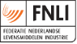
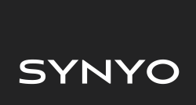
Role Play:
Rewarding suggestions
INDUCE
Towards a Sustainable agro-food INDUstry
Capacity building programmes in Energy efficiency
This project has received funding from the European Union’s H2020 Coordination Support Action under Grant Agreement No.785047.

“This role play is useful to know which ideas are important within the company, to a greater or lesser extent. In this way the ideas are placed in order of importance, according to the general opinion of the group. Similarly, based on the discussions and explanations of the participants you can know the general opinion about certain measures.”

Methodology

Thinking ideas
- A set of papers (for example 3) will be distributed to each participant where you will have to write down three important ideas about Reward Suggestion in the company.

Discussion of ideas
- The participants will be divided into several groups (around 5 people per group). Once in the group, ideas generated by the participants will be discussed.
- The first step will be to group the ideas by types. (Keep in mind that many of the ideas that are generated are the same or similar, also that many ideas can be the solution of others).
- In this way, each idea will not be a "simple concept", but it will be developed along with similar ideas.
- Finally, among the five members of the group, they should discuss which is the five most important ideas for them and how to implement it in the company. Criteria such as:
  - Ease of Implementation
  - Encourage workers
Likewise, the group will have to discuss about the criteria for prioritizing the best suggestions of employees or group rewards related to improve energy efficiency in the company.

Presentation of ideas
- In this phase, each group will present their 3 ideas to the other groups, they should explain the importance of the ideas, which is the reason why the idea should be implemented, the selection criteria previously named. They should also explain the inconveniences of it.The rest of the participants can ask the questions they consider necessary.

Analysis of ideas
- In this phase, all the participants together will put in order the ideas generated by the groups. For this, the colored notes will be used.
- Each participant has a paper of each color (red, orange and green), although he is not obliged to use all of them.
  - Green notes will be used to identify the most suitable idea for them.
  - Orange notes will be used for ideas that should be studied more elaborately.
  - Red notes will be used for the idea in which you are against. In the case of using a red note, it should be explained by them.

Final image
- In this way, the conclusions of this Role Play are recorded a very visual way and the „top management“ can write down to study the implementation of the different ideas.
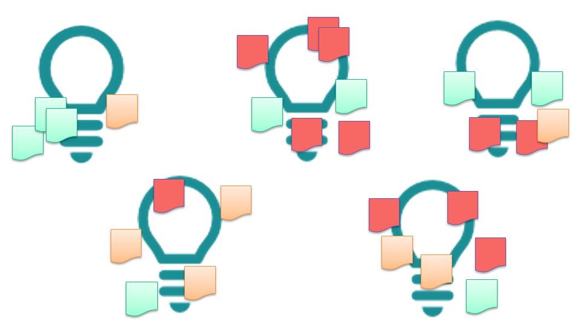
- Similarly, the prioritization of the suggestion criteria should be included in a table similar to the following:
Clasification | Suggestions of employees or group rewards
1 |  | The best suggestion
2
3
4
5
… |  | The worst suggestion

Materials
- Stickers for initial ideas.
- Large sheets where write the final ideas of each group.
- Stickers or colours note (green, orange and red).

