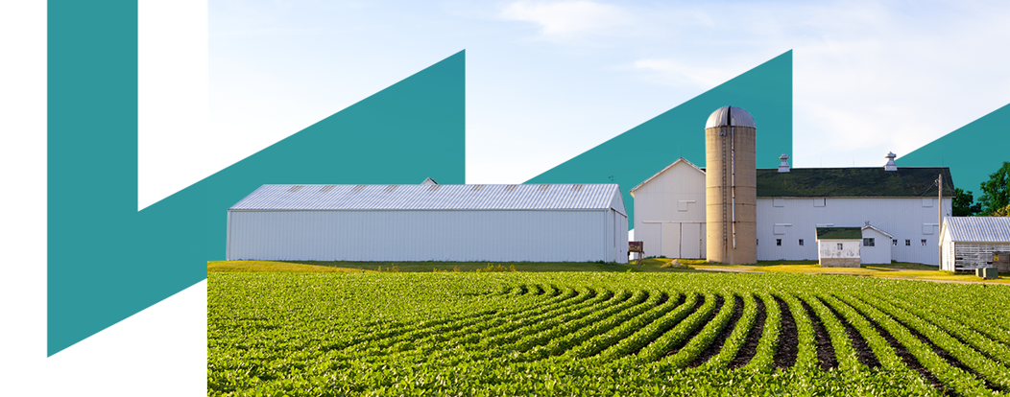

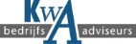
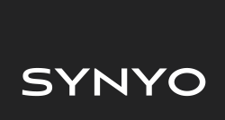
Towards a Sustainable Agro-Food Industry.
Capacity Building Programmes in Energy Efficiency.

Methodology:
Playful pedagogy of collective intelligence
This project has received funding from the European Union’s H2020 Coordination Support Action under Grant Agreement No.785047.

This project has received funding from the European Union’s H2020 Coordination Support Action under Grant Agreement No.785047.
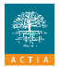

Why?
We learn better by constructing our ideas. 10 years ago, this methodology saved his business by redefining his strategy with pieces of construction.
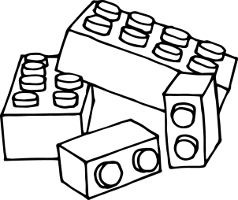
General advice:
- Use the verbs "build" or "represent" rather than "play".
- Important to keep a constructive dynamic, limit the time of construction.
- The methodology’s Principle: There are no chairs, we stand up and build on a table.
Number of participants:
- From 6 to 12 at maximum.
Initiation (1 hour)
- Action 1: Reproduce a model to get used to handle bricks. Duration 15 minutes
- Action 2: Express expectations of the day: 15 minutes of construction / 15 minutes of restitution
- Other options about Action 2: Express mood with pieces / Build a tower with a symbol

Application to energy training
- Before starting, the trainer should explain the aim of this exercise and what is expected at the end.
- The main idea is to build different energy consumption systems throughout the day. We have 2 levels of work:
- Secondary energy generating equipment in the company
- Cold groups
- Compressed air
- Steam boiler / hot water
……
- Primary / secondary energy consuming equipment in the company
- For the process: oven, cooker, grinders, various engines
- For buildings: lighting, need for cold / hot out of process
- Other needs: ex cleaning
It would be ideal if the exercise is practiced in binomial or trinomial groups. Each group will build a model (Construction of individual models by 2). The goal is to have 4 to 6 groups in all.
According to their daily missions (maintenance, production, cleaning ...), each group have to choose one model to build:
- Secondary energy production equipment
- Equipment or operation using co energy
- Or both, for example: steam boiler and autoclave consuming steam

They are invited to represent the monitoring of these equipment and the fundamental points concerning energy efficiency. Then over time, build links between different utilities, and the needs of production.
Note: They have the possibility to represent different physical / data links.
Different types of links: rigid / moderately rigid / flexible.
Construction time: 20 min
- At the end of this exercise, we should stand up to see the different models that have been built. Each group presents its model and the planned improvement actions.
Option: At the end of the presentations, we may let the other groups complete the models presented. They will have 10 minutes of construction. After that, the trainer will hold a round-table discussion about the additional ideas.

- Establish an action plan:
- Identify the main guidelines and precise the actions to do in first place
- Write on a post-it the actions proposed by participants
- Then, everyone will have 3 bricks to vote. Participants should put their bricks on the post-it of their colleagues.

- The trainer should make everybody react on the models, after that they will take again the key concepts that emerge at the same time on the board.

Tips:
Small red bricks or colored flags can be used to mark points of attention.
Red is not good, a preference for green.

